Day 10 — Partitioning

build.sbt is the build configuration file for the Scala project.
We specify:
- Scala version → 2.12.18
- Project name → Day10-Partitioning
- Spark Core → 3.5.1
Spark's RDD API provides operations such as repartition, coalesce, and partition-aware Pair RDD operations
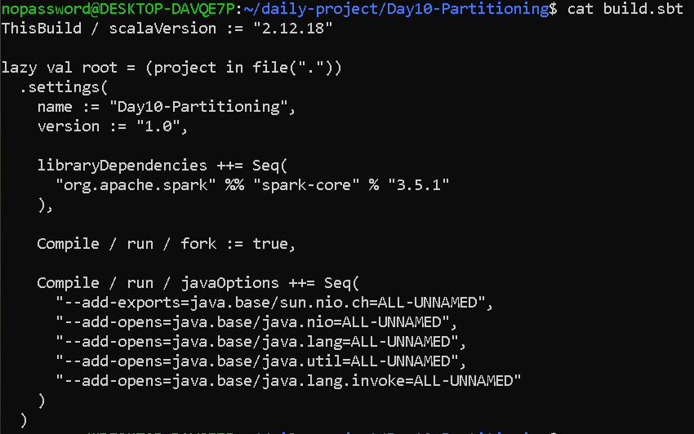

cat src/main/scala/Da
y10Partitioning.scala
import org.apache.spark.{SparkConf, SparkContext}
import org.apache.spark.HashPartitioner

object Day10Partitioning {

def main(args: Array[String]): Unit = {

val conf = new SparkConf()
.setAppName("Day10-Partitioning")
.setMaster("local[*]")

val sc = new SparkContext(conf)

sc.setLogLevel("WARN")

println("==========================================")
println("DAY 10 - PARTITIONING")
println("==========================================")

// --------------------------------------------------
// 1. Create an RDD with too few partitions
// --------------------------------------------------

val numbers = 1 to 20

val rdd = sc.parallelize(numbers, 2)

println("\n1. Initial RDD")
println("Number of elements: " + rdd.count())
println("Initial partitions: " + rdd.getNumPartitions)

// --------------------------------------------------
// 2. Inspect partition contents
// --------------------------------------------------

println("\n2. Initial Partition Contents")

rdd.mapPartitionsWithIndex {
case (index, iterator) =>
Iterator(
s"Partition $index: ${iterator.mkString(", ")}"
)
}.collect().foreach(println)

// --------------------------------------------------
// 3. Repartition - increase partitions
// --------------------------------------------------

val repartitionedRDD = rdd.repartition(4)

println("\n3. After repartition(4)")
println("Number of partitions: " +
repartitionedRDD.getNumPartitions)

repartitionedRDD.mapPartitionsWithIndex {
case (index, iterator) =>
Iterator(
s"Partition $index: ${iterator.mkString(", ")}"
)
}.collect().foreach(println)

// --------------------------------------------------
// 4. Coalesce - decrease partitions
// --------------------------------------------------

val coalescedRDD = repartitionedRDD.coalesce(2)

println("\n4. After coalesce(2)")
println("Number of partitions: " +
coalescedRDD.getNumPartitions)

coalescedRDD.mapPartitionsWithIndex {
case (index, iterator) =>
Iterator(
s"Partition $index: ${iterator.mkString(", ")}"
)
}.collect().foreach(println)

// --------------------------------------------------
// 5. Pair RDD
// --------------------------------------------------

val sales = sc.parallelize(
Seq(
("Laptop", 100000),
("Mouse", 500),
("Keyboard", 1500),
("Laptop", 80000),
("Mouse", 700),
("Monitor", 20000),
("Keyboard", 2000),
("Laptop", 90000)
),
2
)

println("\n5. Pair RDD")
println("Initial partitions: " +
sales.getNumPartitions)

// --------------------------------------------------
// 6. partitionBy
// --------------------------------------------------

val partitionedSales =
sales.partitionBy(new HashPartitioner(4))

println("\n6. After partitionBy(HashPartitioner(4))")
println("Number of partitions: " +
partitionedSales.getNumPartitions)

partitionedSales.mapPartitionsWithIndex {
case (index, iterator) =>
Iterator(
s"Partition $index: ${iterator.mkString(", ")}"
)
}.collect().foreach(println)

// --------------------------------------------------
// 7. Aggregate data
// --------------------------------------------------

val totalSales = partitionedSales
.reduceByKey(_ + _)

println("\n7. Total Sales By Product")

totalSales.collect().foreach {
case (product, amount) =>
println(s"$product -> $amount")
}

// --------------------------------------------------
// 8. Scenario: dataset with too few partitions
// --------------------------------------------------

println("\n8. Scenario: Too Few Partitions")

val smallPartitionRDD =
sc.parallelize(1 to 100, 1)

println(
"Original partitions: " +
smallPartitionRDD.getNumPartitions
)

val optimizedRDD =
smallPartitionRDD.repartition(4)

println(
"Optimized partitions: " +
optimizedRDD.getNumPartitions
)

println(
"Dataset count after repartition: " +
optimizedRDD.count()
)

println("\n==========================================")
println("DAY 10 COMPLETED")
println("==========================================")

sc.stop()
}
}

OUTPUT—

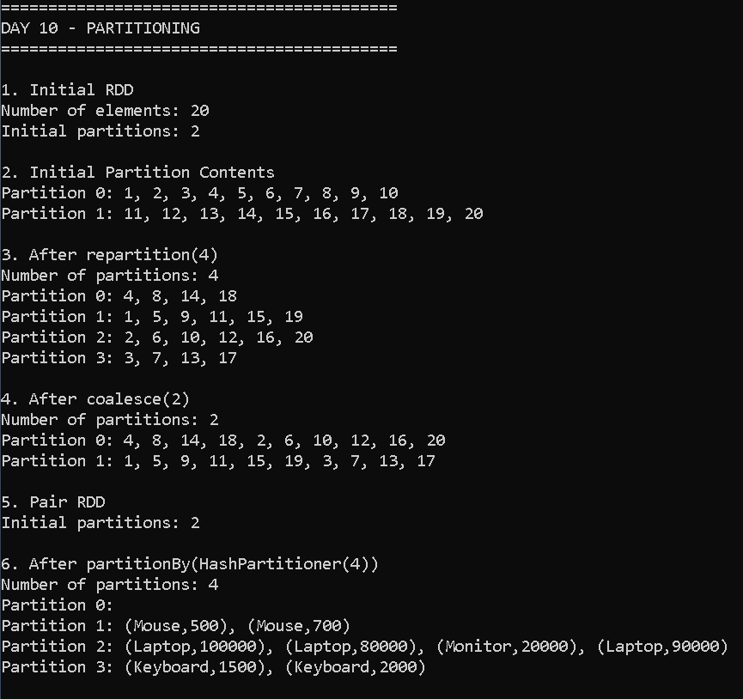

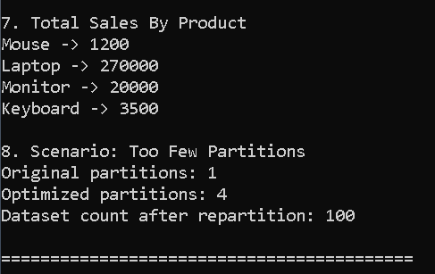

[[ for reference..

Understand the first part — Creating an RDD
This code:
val numbers = 1 to 20

val rdd = sc.parallelize(numbers, 2)
creates an RDD containing numbers from 1 to 20.
The important part is:
sc.parallelize(numbers, 2)
The 2 means:
Create the RDD using 2 partitions.
So:
20 records
↓
Partition 0
Partition 1

6. Inspect partition count
We use:
rdd.getNumPartitions
For our RDD:
println("Initial partitions: " + rdd.getNumPartitions)
Expected:
Initial partitions: 2

Theory
getNumPartitions returns the number of partitions currently present in an RDD.
It is useful when diagnosing Spark performance.
For example:
RDD → 1 partition
may indicate insufficient parallelism for a large dataset.
Whereas:
RDD → 10,000 partitions
may create many small tasks and scheduling overhead.

7. Inspect actual data inside each partition
We use:
mapPartitionsWithIndex
Example:
rdd.mapPartitionsWithIndex {
case (index, iterator) =>
Iterator(
s"Partition $index: ${iterator.mkString(", ")}"
)
}
This lets us see which records belong to each partition.

Theory
mapPartitionsWithIndex provides:
- partition index
- iterator containing the records in that partition
It is useful for debugging and understanding data distribution.
Example:
Partition 0: 1, 2, 3, ...
Partition 1: 11, 12, 13, ...
The exact distribution can depend on how the RDD was created.

8. repartition() — increasing partitions
We use:
val repartitionedRDD = rdd.repartition(4)
Initially:
2 partitions
After:
repartition(4)
we get:
4 partitions

Theory
repartition() creates exactly the requested number of partitions and redistributes the data using a shuffle. Spark's documentation specifically notes that repartition can increase or decrease parallelism and always involves redistributing the data.
Conceptually:
Before:

Partition 0
Partition 1

↓
SHUFFLE

After:

Partition 0
Partition 1
Partition 2
Partition 3

Why increase partitions?
Suppose we have:
1 huge partition
and a machine has multiple CPU cores.
Only one task may be processing that partition, leaving other resources underused.
Increasing partitions can provide more parallel tasks.

9. Why too few partitions is a problem
This is the main scenario in your assignment.
Imagine:
Large dataset
↓
1 partition
↓
1 task
↓
Poor parallelism
Even if your computer has several CPU cores, having only one partition can limit the amount of parallel work.
Instead:
Large dataset
↓
4 partitions
↓
4 tasks
↓
More parallelism
Spark documentation explains that Spark runs one task per partition and that partition count controls the level of parallelism.

10. coalesce() — decreasing partitions
We use:
val coalescedRDD = repartitionedRDD.coalesce(2)
Before:
4 partitions
After:
2 partitions

Theory
coalesce() is generally used to reduce the number of partitions.
One important advantage is that reducing partitions with coalesce() can avoid a full shuffle.
For example:
4 partitions

P0 ─┐
P1 ─┴──→ P0

P2 ─┐
P3 ─┴──→ P1
The Spark documentation describes coalesce as useful for reducing partitions and notes that it can avoid a shuffle when reducing partition count.

11. repartition() vs coalesce()
This is very important for viva.
Feature | repartition | coalesce
Main purpose | Increase/decrease partitions | Usually decrease
Shuffle | Yes | Usually no when reducing
Data redistribution | More complete | Less expensive
Performance | More expensive | Usually cheaper
Example | 2 → 4 | 4 → 2

Easy viva answer
Repartition is used when I need to redistribute data and can increase or decrease the number of partitions. It performs a shuffle. Coalesce is mainly used to reduce partitions and can avoid a shuffle, making it cheaper.

12. Pair RDD
Now we create:
val sales = sc.parallelize(
Seq(
("Laptop", 100000),
("Mouse", 500),
...
),
2
)
Each record is:
(Key, Value)
For example:
("Laptop", 100000)
Here:
Key = Laptop
Value = 100000
This is called a Pair RDD.

13. partitionBy()
We use:
val partitionedSales =
sales.partitionBy(new HashPartitioner(4))
This creates a partitioned Pair RDD using a HashPartitioner.

Theory
partitionBy() partitions key-value records according to a partitioner.
With:
new HashPartitioner(4)
we request:
4 partitions
The hash of each key determines which partition receives that record.
Conceptually:
Laptop → hash → Partition ?
Mouse → hash → Partition ?
Monitor → hash → Partition ?
Records with the same key are mapped consistently to the same partition under the hash partitioner.
This is especially useful for operations involving keys, such as aggregations and joins.

14. Why partitioning helps Pair RDDs
Suppose we have:
("Laptop", 100000)
("Laptop", 80000)
("Laptop", 90000)
We eventually perform:
reduceByKey(_ + _)
Spark needs all values for the same key to be brought together for aggregation.
Partitioning helps organize records by key.

Theory
Many Pair RDD operations use partitioning to organize key-value data. Shuffle operations redistribute data across partitions so records needed together can be processed together.

15. reduceByKey()
Our code:
val totalSales = partitionedSales
.reduceByKey(_ + _)
means:
For each product, add all sales amounts belonging to that product.
For example:
Laptop:
100000
80000
90000

Total:
270000
Expected output will be similar to:
Laptop -> 270000
Mouse -> 1200
Keyboard -> 3500
Monitor -> 20000
The order may differ because distributed processing does not guarantee the order returned by collect().

16. Assignment scenario — too few partitions
This is the most important part:
val smallPartitionRDD =
sc.parallelize(1 to 100, 1)
We deliberately create:
100 records
1 partition
Then:
val optimizedRDD =
smallPartitionRDD.repartition(4)
Now:
100 records
↓
4 partitions
We check:
optimizedRDD.getNumPartitions
Expected:
Optimized partitions: 4

Report explanation
The dataset initially contained 100 records in a single partition. This configuration limits parallelism because Spark processes one task per partition. To improve parallel processing, the RDD was repartitioned into four partitions. repartition(4) performs a shuffle to redistribute the records across four partitions. This demonstrates how increasing the partition count can address a dataset suffering from too few partitions
…]]

